

NAME : IMRAN ALI

ROLL NO : 110855

SEMESTER : THIRD

DEPARTMENT : INFORMATION TECHNOLOGY

TOPIC : TASK FILES PKT

SUBMITTED TO : MISS SAHRISH KHAN

    - REPETER CONNECTION OF LAN

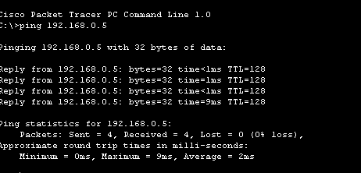
PING RESULT

IN this network we take one switch one router .
switch is connected with two laptops and a pc is connected with router.
We will assign laptop and pc with IP address and their gate way.
REPEATER CONNECTION OF CLASS TASK
PING RESULT:
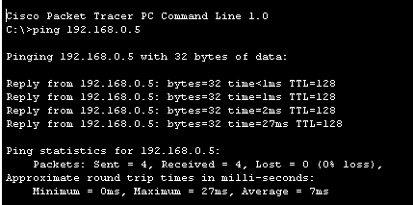
CONFIGRAUTION:
First we take a switch and connected it with two pc .
We take a repeater and connected with a single pc .
Then we take a central switch and and connted a switch and repeater with central switch.
PRACTICAL 3 REPEATER
PING RESULT 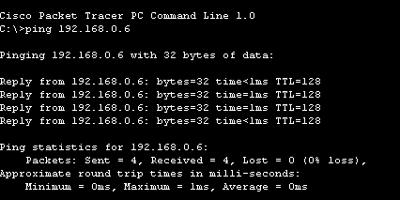
CONFIGRUATION:
        - First we take two switch and one repeater and connected with a pcs.
        - Then we take one hub and connected with two pcs .
        - Then we assign a IP address and gateway to the pcs .
HOME TASK OF REPEATER
Ping result:
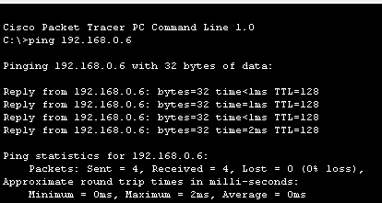
CONFIGRUATIN :
        - First we take two switch and one repeater and connected with a pcs.
        - Then we take one hub and connected with two pcs .
        - Then we assign a IP address and gateway to the pcs.
        - Then we take a router and connected it with a pc.
        - Then we will assign a gate way to the router we will
        - Connected a router with a copper straight through.
CLASS 1 TASK
PING RESULT:
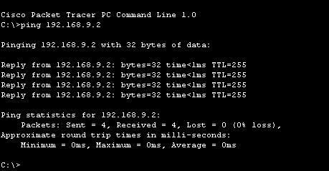
Configuration :
      - First we a take a router switch and two pcs
      - Then we connected a router with a switch and a switch is connectd
      - With pc.
      - Then the router is connected with a pc .
      - Then we will assign a pc with Ip address and a router with different
      - Gateway.
CLASS TASK 2
PING RESULT:
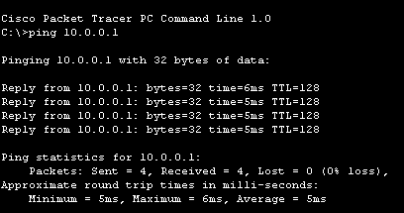
CONFIGRUATION:
        - First we take switch and connectd with a two pcs.
        - And the switch is connected with a server.
        - Then we will assign a address to the pcs .
        - Then we set a server at DHCP
Class task 3
Ping result :

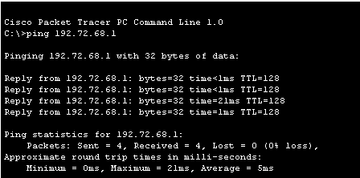
CONFIGRUATION:

. first we take a pt repeater and two pcs.
Then we connected these pcs with a wire to a repeater.
Then we give IP address to computer and network start workig.
Class task 4
Ping result:
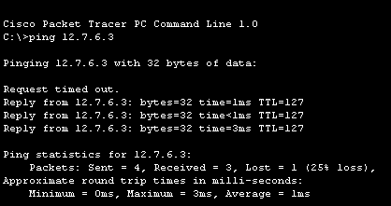
Configuration:
      - In this network we design a wan network with router.
      - One side we will take 2 pcs and one phone and connected it with switch
      - Then the switch also connected with another switch.
      - On the other hand we take switch repeater and hub switch take 2 pcs
      - Hub and repeater also take one computer and the switch is connected
      - With a another switch and switch contain another computer
      - Then we will connected these network with a router .
      - We will assign a address to the computer and also give gateway.
Class task 5
Ping result :
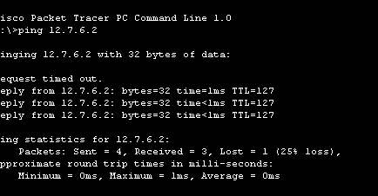
configuration:
In this network we design a wan network with router.
One side we will take 2 pcs and one phone and connected it with switch
Then the switch also connected with another switch.
On the other hand we take switch repeater and hub switch take 2 pcs
Hub and repeater also take one computer and the switch is connected
With a another switch and switch contain another computer
Then we add two server on both sides .
Then we will connected these network with a router .
We will assign a address to the computer and also give gateway
Wan network
Ping result

Configuration:
        - We will creat a wan network.
        - We will creat a three lan network using router.
        - After we will connected these lan network with a routers.
        - We will assign a address to computers and servers.
      - And we config the routers also.

